Ukraine Aid and Education Fund Inc

**Incorporation No. A0041502M**

**Secretary:**

Mrs Alison McEwen

8 Sproats Lane

Donald 3480 Ph (03) 54 971328

Fax (03) 54971908

Email: amc12370@bigpond.net.au

**President:**

Mrs Carrie Pearse

PO Box 100

Donald 3480

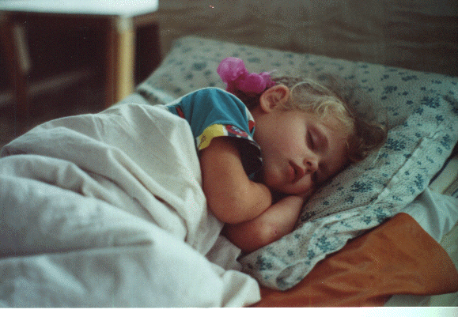**Treasurer:**

Mrs Yvonne Lavell

715 Pinks Rd

Corack 3480

Report

***Annual General Meeting***

***2019***

It is a pleasure to write our Annual Report. We have participated in so many varied activities and contributed to a number of different causes. We have enjoyed the teamwork of conducting the `Look First Op Shop’, welcoming new members onto our team and farewelling others, Also it would be amiss if we did not mention chatting to our valued customers as a vital part of our year.

**Local Donations:** September, 2018 found us in a financial position to be generous to our local churches as we were not sending any further containers to Ukraine or elsewhere. We gave to St Vinnies, Friends and Neighbours, Granite Church and ESA Youth Ministries. Our local organisations, Goodwin Auxiliary, History Group, P&A Society, Carols by Candlelight, Chamber of Commerce are always appreciative of our ongoing support. Through Food Bank and hampers, both at Christmas and during the year, low income families have been supported. Also one family received assistance with fuel vouchers. Having seen firsthand, the drought in Qld and NSW, we were glad that during the past year we supported the appeal for hay. Our own farmers were remembered by contributing to the `Farmers Family Night’. Through giving to MOPS, Kids Club and Ignite Youth Group we encourage the local work with children and their families. Further afield, children of our Victorian prisoners receive a donation through the Angel Tree Appeal – Christmas gifts. A contribution was given to the Donald Recreation Reserve extensions and modifications which are near completion.

**Overseas Aid:** Our interest in the Health Care Project in Timor Leste has continued, supporting village health workers to educate and detect leprosy and other health diagnosis. Freight to Brisbane for forwarding onto Moldova has enabled a large number of handknits to be packed onto pallets being more economical than posting boxes. We are encouraging the

ladies who knit to continue and have value in their articles. Ian and Alison were able to meet Kevin Jones and his wife while in Brisbane. Kevin packs the containers for Moldova. Moldova is the poorest country in Europe. Supporting the summer disability camp in Sumy, Ukraine is much appreciated as it enables families to enjoy holiday time together.

**Hygiene Bags:** Indigenous Communities in the Northern Territory have many needs but one is hygiene items for emergencies. Ian and Alison were able to take thirty hygiene bags containing facewasher, soap in cont., toothbrush in cont., toothpaste, hairbrush and comb. These are proving valuable for a patient being flown out to Darwin Hospital in an emergency. On request sanitary pads are placed in thr bags as well.

**Op Shops in Northern Territory:** During the previous meeting, the suggestion was made to post clothes to Op Shops in NT. There had been Facebook posts asking for items to sell. Although inquiries had been made we had not received replies. However, Ian and Alison were able to take 6 boxes of clothes and handknits to Gapuwiyak and Nygkurr. The indigenous staff at the Gapuwiyak Medical clinic received half the goods and Nygkurr Op Shop the other half. The items were really appreciated – including the rugs -use them for warmth sitting around the campfire. See photos.

**Yermia Wekes is our sponsored child** through Compassion. As each letter is received Alison writes back. Yermia last wrote that he likes his new sandals, enjoyed visiting the beach with his family over Easter, winning an egg and spoon race (using a marble) and buying a secondhand bike. He is now 9 years old.

**Look First Op Shop:** We are all very proud of our Shop- its attractiveness and friendliness. This, of course is achieved by the lovely team of volunteers. Although, **ShopTakings** are down on previous year($2,540.00) the income generated is very good. A dry finish to the year, the overall economy in the country is not growing, retail spending is down and more local competition are all factors contributing to this. However, we are very proud of the service we are providing. Being open longer hours on Christmas Promotion night, the Esoteric Festival and the Town Garage Sale all add to the community spirit the Shop has generated. The shop continues to provide services for Corrective Services and Centrelink. We enjoy including the clients who come through onto the team. Thanks to Carrie and Mark we have a very good working relationship with St Vinnies in St Arnaud as they are recipients of our excess clothes. Our **Facebook** address enjoys a number of hits but needs to be constantly updated. Mark is keeping up with the T & T. We have welcomed Glenys Williams onto the team and farewelled, although not formally Jenny Whitfield, Audrey Spencer, Leonie Spencer and Lorraine Hickmott.

**Bus Tour:** Twelve months ago the Op Shop Tour took us to Birchip, Woomelang, Hopetoun, Beulah, and Warracknabeal. We all enjoyed the day.

**Christmas Break Up:** We enjoyed a luncheon hosted by Jenni and Graham Shilton and Ben Bloomfield in the setting of their lovely garden.

**Volunteer Management Course:** In May, Alison attended a workshop on National Standards for Volunteers. The directive is that each group who involve volunteers have a manual of Vision/Mission Statements, Objectives, Job Descriptions, Code of Conduct etc. We have some of these criteria but a formal manual will need to be written. The presenter was most impressed when Alison said that `we treat our volunteers like gold’ and that we spoil them with a fun day outing - `Op Shop Tour’

**Students – July Aug Sept**

**Victor Boltak –** Manager

**Vinnitsa:** Olia Zwigun, post graduate studies in English, Vita Gladishko, political science,

Olena Shkundia, Obstetrics, David Gladishko, carpenter, Vlad Ponomareva, IT , Tania Boltak, English,

**Refugee English Club**– 4 groups – primary age, teen age and adult

**Sumy:** Herman Nadjafov, journalism, Yaroslav Kosovchenko, electronics, Ira Guzhvenko, Foreign languages/social communications

Sumy Christian Teachers Association & small humanitarian aid fund

**Speaking engagements – Eaglehawk and Charlton**

Early March, Alison was invited to speak at the **World Day of Prayer Service** in Charlton. The service was prepared by the ladies of Slovenia. Slovenia was in the former Soviet Union, and has much in common with Ukraine. We were also guest speakers at Eaglehawk Probus.

**Youth Works** – This separate bank account is funded by finance being transferred into the account and shared for youth group activities and financing young people to attend camps. The recipients appreciate the assistance this gives.

**Thank you**  Glenys for joining the team, we love having you on Tuesday and Wednesday mornings, Thank you Anne, Sally, Dorothy, Dot, Jan, Jenni, Jackie, Josie, Kay, Margaret, Mark, Mary, Shirley, Verna and Max.

***`Rejoice greatly in the Lord always, I will say it again Rejoice! Let your gentleness be evident to all’ – Phil 4; 4&5***

**President:** Carrie Pearse

**Secretary:** Alison McEwen

**Treasurer:** Yvonne Lavell