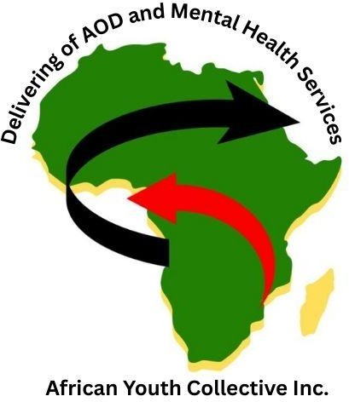

African Youth Collective (AYC)
Full Consolidated Financial Report – FY 2024–2025
CEO: Hakim Alier
President: Charity Marisa
Financial Year Ending: 30 June 2025

- Income Statement
Income Sources

Source | Amount (AUD)
Victoria Youth Fest Funding | 2,000.00
John Template Foundation (Auspice) | 6,000.00

Personal Contributions – Hakim Alier | 2,500.00
Total Income | 10,500.00

- Expenditure Summary
  - Victoria Youth Fest ($2,000)

Expense Category | Amount
Security | 500.00
Food | 500.00
Council Parking | 500.00
Printing, Advertising, Transport | 500.00
Total Youth Fest Expenses | 2,000.00

  - John Template Foundation / Auspice Expenses ($4,081.36)

Category | Amount

Online order | 1,120.0  0
Additional shipping cost | 25.00
Artwork setup | 49.00
Branding & Promotional Materials | 767.96
Ben Q Furniture & Equipment (personal contribution) | 2,000.0  0
Total Auspice Expenses | 4,081.3  6
Note: Ben Q & Abas Van expenses were covered personally by Hakim Alier
→ Do not reduce AYC cash.

  - Website Expenses (IT, Email, Domain, Hosting)
(Paid by Hakim Alier – Personal Expenses, Not Deducted From AYC Funds)

Receipt No. | Dat e | Item | Email/Domain | Subtot al | Tax | Total | Curren cy | Card
3943340  565 | 202  5-1  1-1  0 | Micros oft 365 Renew al | ceo@aycol.org | 15.41 | 1.5  4 | 16.9  5 | AUD | Visa 1243

3935653  201 | 202  5-1  0-3  1 | Micros oft 365 Renew al | info@aycol.org | 15.41 | 1.5  4 | 16.9  5 | AUD | MasterC ard 5527
3915513  601 | 202  5-1  0-0  8 | .ORG  Domai n Renew al | aycol.org | 36.05 | 3.6  3 | 39.9  8 | AUD | MasterC ard 5527
3915513  601 | 202  5-1  0-0  8 | Full Domai n  Protect ion | aycol.org | 13.59 | 1.3  6 | 14.9  5 | AUD | MasterC ard 5527
3915371  686 | 202  5-1  0-0  6 | Micros oft 365 Renew al | info@aycol.org | 15.41 | 1.5  4 | 16.9  5 | AUD | Visa 1243
3915370  370 | 202  5-1  0-0  6 | Micros oft 365 Renew al | ceo@aycol.org | 12.33 | 1.2  3 | 13.5  6 | AUD | MasterC ard 6574
3782547  998 | 202  5-0  6-1  4 | Micros oft 365 Email Essenti als | president@ayco l.org | 23.88 | 2.3  9 | 26.2  7 | USD | Visa 1243

3782518  341 | 202  5-0  6-1  4 | Websit e +  Marketi ng  Premiu m | aycol.org | 272.1  8 | 27.  22 | 299.  40 | AUD | Visa 1243
3782518  341 | 202  5-0  6-1  4 | Micros oft 365 Free Trial | mashinkok@aa yp.org | 0.00 | 0.0  0 | 0.00 | AUD | Visa 1243

  - Springwater – Kiewa Valley (Personal Expense)
Cost: $60 every 3 weeks
Annual Total:
    - 52 ÷ 3 = 17.33 cycles per year

    - 17.33 × $60 = $1,040.00 per year

Note: Paid by Hakim Alier personally – does not reduce AYC funds.

  - Total Expenses (AYC Funds Only)

Category | Amount

Youth Fest | 2,000.00
Auspice Expenses | 4,081.36
TOTAL EXPENSES (AYC) | 6,081.36

- Surplus / Remaining Funds

Description | Amount (AUD)
Total Income | 10,500.00
Total AYC Expenses | (6,081.36)
Net Surplus / Remaining Funds | 4,418.64

Breakdown of Surplus

Category | Amount
Auspice Funds (held by Africause) | 1,918.64
Personal Contributions – Hakim Alier (Ben Q, Van, Springwater, Website, Domain, etc.) | 3,540.00 + website receipts (personal)

Total Surplus / Non-AYC Funds | 5,458.64+ (personal & auspice)
Personal expenses do not reduce AYC operating funds.

- Balance Sheet (As at 30 June 2025)
Assets

Asset | Amount
Cash on Hand / Bank | 0.00
Auspiced Funds (held by Africause) | 1,918.64
Personal Contributions – Hakim Alier | 3,540.00+
Total Assets | 4,418.64 (AYC)
Liabilities & Equity

Item | Amount
Liabilities | 0.00
Net Equity / Surplus | 4,418.64

Total Liabilities & Equity | 4,418.64

